# Chapter 1

# Introduction

“ONLINE VOTING SYSTEM” is an online voting technique. In this system people who have citizenship of India and whose age is above 18 years of age and any sex can give his\her vote online without going to any physical polling station. There is a database which is maintained in which all the names of voters with complete information are stored.

In “ONLINE VOTING SYSTEM” a voter can use his\her voting right online without any difficulty. He\She has to be registered first for him/her to vote. Registration is mainly done by the system administrator for security reasons. The system Administrator registers the voters on a special site of the system visited by him only by simply filling a registration form to register voter. Citizens seeking registration are expected to contact the system administrator to submit their details. After the validity of them being citizens of India has been confirmed by the system administrator by comparing their details submitted with those in existing databases such as those as the Registrar of Persons, the citizen is then registered as a voter.

After registration, the voter is assigned a secret Voter ID with which he/she can use to log into the system and enjoy services provided by the system such as voting. If invalid/wrong details are submitted, then the citizen is not registered to vote.

## 1.1 Project description

Online voting system project is implemented in Android Studio platform using SQLite database as back end. Main aim of online voting system is to develop an online application like online reservation system, for citizens who are above 18 years of age to vote through online. Using these system citizens of India can vote through online without visiting polling booth. A centralized database is maintained by election commission of India where citizens information is maintained whenever citizen is using online voting system his/her information is authenticated with the data present in database if user is not in the list, he cannot use online voting system.

## 1.2 Project Scope

The project scope for an online voting application includes the following:

* User registration: Users should be able to register themselves on the platform by providing their basic details such as name, email address, and phone number.
* Secure login: The system should have a secure login mechanism to ensure that only registered users can access the voting features.
* Candidate registration: Candidates for the election should be able to register themselves by providing their basic details and the position they are running for.
* Voting process: The system should have a user-friendly interface for the voting process. Users should be able to select the candidate of their choice and submit their vote securely.
* Vote counting: The system should have an automated vote counting process to ensure accurate results.
* Security and privacy: The online voting application should be highly secure to prevent any fraudulent activities or hacking attempts. It should also ensure the privacy of voters to maintain confidentiality.
* Accessibility: The online voting application should be accessible to all eligible voters irrespective of their location, device, or ability.
* Administration: The system should have an administration panel to manage and monitor the voting process, including user and candidate registration, vote counting, and result declaration.

**1.3 Hardware / Software used in Project**

Hardware Requirement

* System: Pentium i3 Processor
* Hard Disk :500 GB minimum
* Monitor: 15’’ LED
* Input Devices :Keyboard, Mouse
* Ram: 2 GB

Software Requirement

* Windows 7/8/10 (32- bit or 64-bit)
* ANDROID STUDIO
* 4GB RAM MinimumProcessori3 or i5

Technology Used

* JAVA
* SQLite

The ONLINE VOTING SYSTEM-INDIA shall reduce the time spend making long queues at the polling stations during voting. It shall also enable the voters to vote from any part of the globe as explained since this is an online application available on the internet. Cases of vote miscounts shall also be solved since at the backend of this system resides a well-developed database using MYSQL that can provide the correct data once it’s correctly queried. Since the voting process shall be open as early as possible, the voters shall have ample time to decide when and whom to vote for.

1.3 Hardware / Software used in Project

Hardware Requirement

* System: Pentium i3 Processor
* Hard Disk :500 GB minimum
* Monitor: 15’’ LED
* Input Devices :Keyboard, Mouse
* Ram: 2 GB

Software Requirement

* Windows 7/8/10 (32- bit or 64-bit)
* ANDROID STUDIO
* 4GB RAM MinimumProcessori3 or i5

Technology Used

* JAVA

# Chapter 2

# Feasibility Study

## Old Methods of Voting

1. Paper-based voting: The voter gets a blank ballot and use a pen or a marker to indicate he want to vote for which candidate. Hand counted ballots is a time and labour consuming process, but it is easy to manufacture paper ballots and the ballots can be retained for verifying, this type is still the most common way to vote.

2. Lever voting machine: Lever machine is peculiar equipment, and each lever is assigned for a corresponding candidate. The voter pulls the lever to poll for his favourite candidate. This kind of voting machine can count up the ballots automatically. Because its interface is not user friendly enough, giving some training to voters is necessary.

3. Optical voting machine:

After each voter fills a circle correspond to their favourite candidate on the blank ballot, this machine selects the darkest mark on each ballot for the vote then computes the total result. This kind of machine counts ballots rapidly. However, if the voter fills over the circle, it will lead to the error result of optical scan.

Recent years, a considerable number of countries has adopted E-voting for their official elections. These countries include America, Belgium, Japan and Brazil.

The main feasible study of OVS include:

Provision of improved voting services to the voters through fast, timely and convenient voting.

Reduction of the costs incurred by the Kenyan Electoral Commission during voting time in paying the very many clerks employed for the sake of the success of the manual system. Check to ensure that the members who are registered are the only ones to vote. Cases of “Dead People” voting are also minimized.

Online voting system (OVS) will require being very precise or cost cutting to produce an effective election management system.

# 2.1 Technical feasibility

An online voting (E-voting) system is a voting system in which the election data is recorded, stored, and processed primarily as digital information. The research on electronic voting is a very important topic for the progress of democracy. If a secure and convenient electronic voting system is provided, it will be used more frequently to collect people's opinion through cyberspace.

Traditional paper-based voting can be time consuming and inconvenient. E-voting not only accelerates the whole process but makes it less expensive and more comfortable for the voters and the authorities as well. It also reduces the chances of the errors. E-voting system should provide all basic features that conventional voting does, further should furnish more services to make the process more trusted and secure.

It Maintains all The Information of all the Candidates and Votes.

1.It checks Voter have Voted or Not

2.You can see All the Information Related to any Voting System Online.

3. It Increase the Voting Percentage.

4.Finally It makes Easy Voting by Avoiding problems like

* Security,
* Booth capturing*.*

## 2.2 Operational Feasibility

Electronic voting promises to greatly improve the general experience of voting and democratic participation. However, the security of electronic elections is of prime importance. Our paper deals with the question which organizational and technical requirements an institution must satisfy in order to provide a secure operational environment to carry out secure electronic elections. Our findings provide a basis for design and evaluation of such a secure operational environment to provide secure electronic elections. Hence our results are of great value for all institutions which want to perform secure electronic elections.

## 2.3 Behavioural Feasibility

In this user who is above 18 year’s register his/her information on the database and when he/she want to vote he/she has to login by his id and password and can vote to any party only single time. Voting detail store in database and the result is displayed by calculation. By online voting system percentage of voting is increases. It decreases the cost and time of voting process. It is very easy to use and It is vary less time consuming. It is very easy to debug.

# Chapter 3

# Database Design

SQLite Database is an open-source database provided in Android which is used to store data inside the user’s device in the form of a Text file. We can perform so many operations on this data such as adding new data, updating, reading, and deleting this data. SQLite is an offline database that is locally stored in the user’s device, and we do not have to create any connection to connect to this database.

Data is stored in the SQLite database in the form of tables. When we stored this data in our SQLite database it is arranged in the form of tables that are similar to that of an excel sheet. Below is the representation of our SQLite database which we are storing in our SQLite database.

**3.1 Flow Chart**

## 3.2 Use Case Diagram

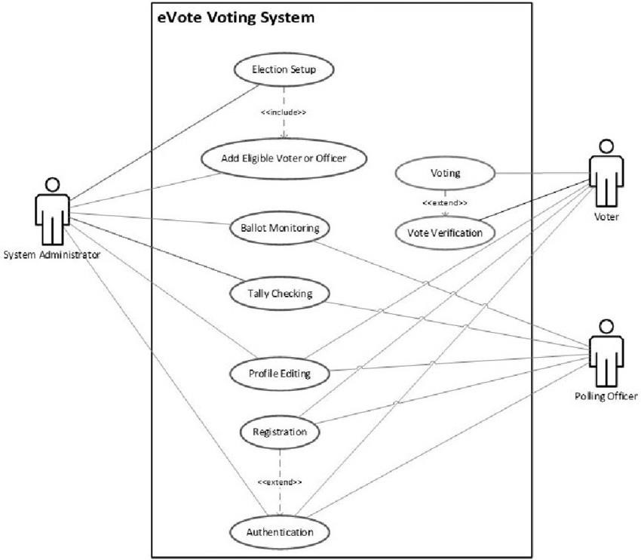

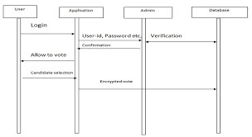**3.3 Sequence Diagram**

# Diagram Description automatically generatedChapter 4

# Form Design

**4.1 Input / Output Form (Screenshot)**

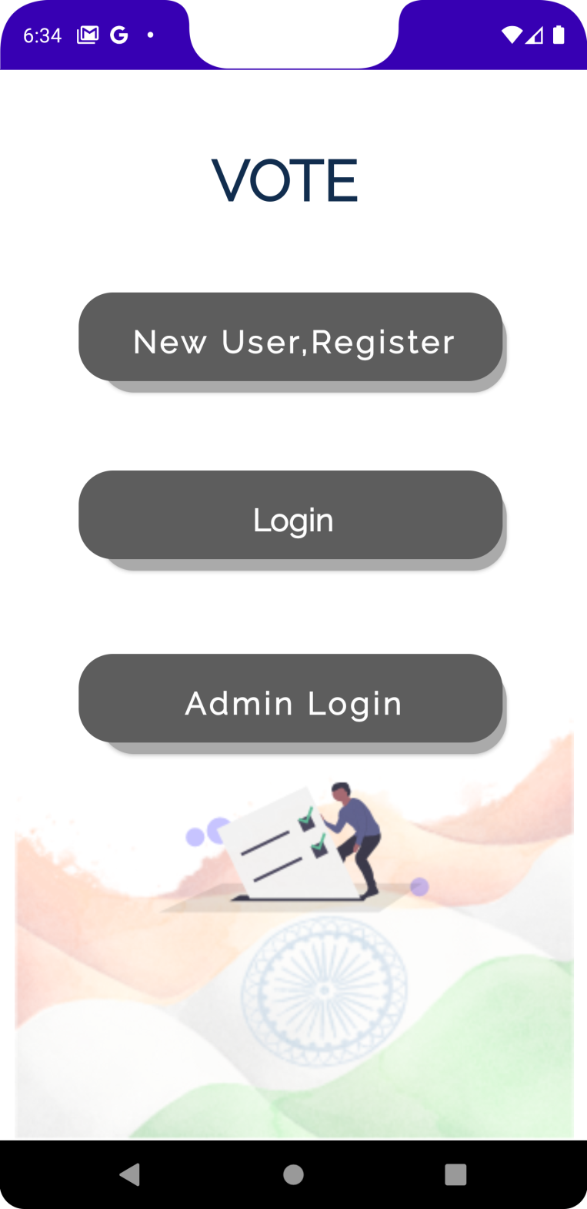

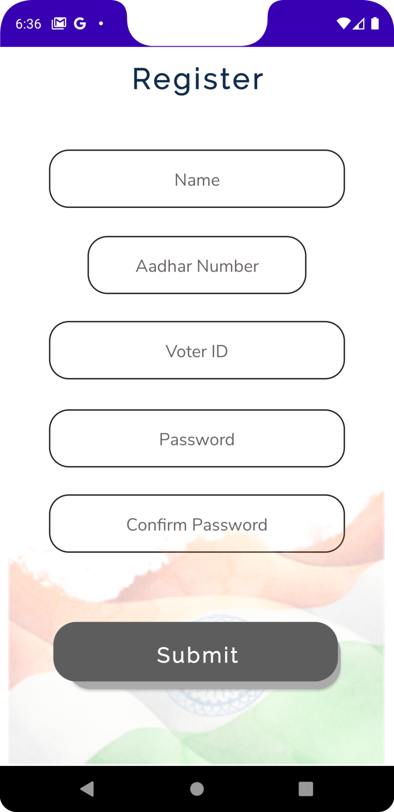

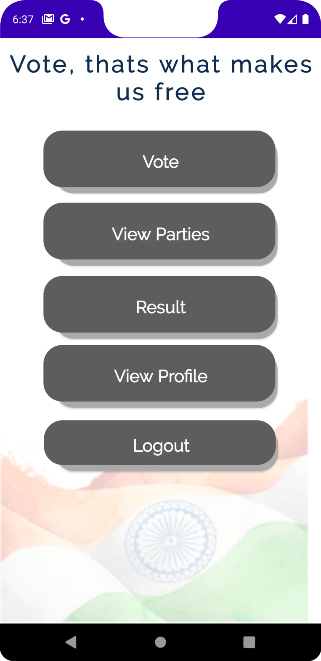

**Chapter 5**

**Coding**

Module wise code

1.Add Party

<?xml version="1.0" encoding="utf-8"?>  
<androidx.constraintlayout.widget.ConstraintLayout xmlns:android="http://schemas.android.com/apk/res/android"  
 xmlns:app="http://schemas.android.com/apk/res-auto"  
 xmlns:tools="http://schemas.android.com/tools"  
 android:layout_width="match_parent"  
 android:layout_height="match_parent"  
 android:background="@color/white"  
 tools:context=".AddParty">  
  
 <Button  
 android:id="@+id/addpartyb"  
 android:layout_width="300dp"  
 android:layout_height="68dp"  
 android:layout_marginBottom="294dp"  
 android:background="@drawable/custombutton"  
 android:fontFamily="@font/raleway"  
 android:gravity="center"  
 android:text="Add Party"  
 android:textAlignment="center"  
 android:textAllCaps="false"  
 android:textAppearance="@style/TextAppearance.AppCompat.Large"  
 android:textColor="#FDFDFD"  
 android:textSize="22sp"  
 android:textStyle="bold"  
 android:typeface="sans"  
 app:layout_constraintBottom_toBottomOf="parent"  
 app:layout_constraintEnd_toEndOf="parent"  
 app:layout_constraintHorizontal_bias="0.494"  
 app:layout_constraintStart_toStartOf="parent"  
 app:layout_constraintTop_toBottomOf="@+id/cname"  
 app:layout_constraintVertical_bias="1.0" />  
  
 <EditText  
 android:id="@+id/pname"  
 android:layout_width="wrap_content"  
 android:layout_height="51dp"  
 android:layout_marginBottom="66dp"  
 android:background="@drawable/customet"  
 android:ems="10"  
 android:fontFamily="@font/nunito_sans"  
 android:hint="Party Name"  
 android:inputType="textPersonName"  
 android:textAlignment="center"  
 android:textColorHint="#6A6464"  
 android:textColor="#090909"  
 android:textSize="18sp"  
 android:typeface="sans"  
 app:layout_constraintBottom_toTopOf="@+id/addpartyb"  
 app:layout_constraintEnd_toEndOf="parent"  
 app:layout_constraintStart_toStartOf="parent"  
 app:layout_constraintTop_toBottomOf="@+id/cname" />  
  
 <EditText  
 android:id="@+id/cname"  
 android:layout_width="wrap_content"  
 android:layout_height="51dp"  
 android:layout_marginBottom="36dp"  
 android:background="@drawable/customet"  
 android:ems="10"  
 android:fontFamily="@font/nunito_sans"  
 android:hint="Candidate name"  
 android:inputType="textPersonName"  
 android:textAlignment="center"  
 android:textColorHint="#6A6464"  
 android:textColor="#090909"  
 android:textSize="18sp"  
 android:typeface="sans"  
 app:layout_constraintBottom_toTopOf="@+id/pname"  
 app:layout_constraintEnd_toEndOf="parent"  
 app:layout_constraintStart_toStartOf="parent"  
 app:layout_constraintTop_toBottomOf="@+id/textView2" />  
  
 <TextView  
 android:id="@+id/textView2"  
 android:layout_width="wrap_content"  
 android:layout_height="wrap_content"  
 android:layout_marginBottom="43dp"  
 android:layout_marginTop="54dp"  
 android:fontFamily="@font/raleway"  
 android:letterSpacing="0.1"  
 android:text="Add Party"  
 android:textAlignment="center"  
 android:textAllCaps="false"  
 android:textAppearance="@style/TextAppearance.AppCompat.Large"  
 android:textColor="#112D4E"  
 android:textSize="30sp"  
 android:textStyle="bold"  
 android:typeface="sans"  
 app:layout_constraintEnd_toEndOf="parent"  
 app:layout_constraintStart_toStartOf="parent"  
 app:layout_constraintTop_toTopOf="parent"  
 app:layout_constraintBottom_toTopOf="@+id/cname"/>  
  
</androidx.constraintlayout.widget.ConstraintLayout>

2.Add Voter

<?xml version="1.0" encoding="utf-8"?>  
<androidx.constraintlayout.widget.ConstraintLayout xmlns:android="http://schemas.android.com/apk/res/android"  
 xmlns:app="http://schemas.android.com/apk/res-auto"  
 xmlns:tools="http://schemas.android.com/tools"  
 android:layout_width="match_parent"  
 android:layout_height="match_parent"  
 android:background="@color/white"  
 tools:context=".AddParty">  
  
 <Button  
 android:id="@+id/addpartyb"  
 android:layout_width="300dp"  
 android:layout_height="68dp"  
 android:layout_marginBottom="294dp"  
 android:background="@drawable/custombutton"  
 android:fontFamily="@font/raleway"  
 android:gravity="center"  
 android:text="Add Party"  
 android:textAlignment="center"  
 android:textAllCaps="false"  
 android:textAppearance="@style/TextAppearance.AppCompat.Large"  
 android:textColor="#FDFDFD"  
 android:textSize="22sp"  
 android:textStyle="bold"  
 android:typeface="sans"  
 app:layout_constraintBottom_toBottomOf="parent"  
 app:layout_constraintEnd_toEndOf="parent"  
 app:layout_constraintHorizontal_bias="0.494"  
 app:layout_constraintStart_toStartOf="parent"  
 app:layout_constraintTop_toBottomOf="@+id/cname"  
 app:layout_constraintVertical_bias="1.0" />  
  
 <EditText  
 android:id="@+id/pname"  
 android:layout_width="wrap_content"  
 android:layout_height="51dp"  
 android:layout_marginBottom="66dp"  
 android:background="@drawable/customet"  
 android:ems="10"  
 android:fontFamily="@font/nunito_sans"  
 android:hint="Party Name"  
 android:inputType="textPersonName"  
 android:textAlignment="center"  
 android:textColorHint="#6A6464"  
 android:textColor="#090909"  
 android:textSize="18sp"  
 android:typeface="sans"  
 app:layout_constraintBottom_toTopOf="@+id/addpartyb"  
 app:layout_constraintEnd_toEndOf="parent"  
 app:layout_constraintStart_toStartOf="parent"  
 app:layout_constraintTop_toBottomOf="@+id/cname" />  
  
 <EditText  
 android:id="@+id/cname"  
 android:layout_width="wrap_content"  
 android:layout_height="51dp"  
 android:layout_marginBottom="36dp"  
 android:background="@drawable/customet"  
 android:ems="10"  
 android:fontFamily="@font/nunito_sans"  
 android:hint="Candidate name"  
 android:inputType="textPersonName"  
 android:textAlignment="center"  
 android:textColorHint="#6A6464"  
 android:textColor="#090909"  
 android:textSize="18sp"  
 android:typeface="sans"  
 app:layout_constraintBottom_toTopOf="@+id/pname"  
 app:layout_constraintEnd_toEndOf="parent"  
 app:layout_constraintStart_toStartOf="parent"  
 app:layout_constraintTop_toBottomOf="@+id/textView2" />  
  
 <TextView  
 android:id="@+id/textView2"  
 android:layout_width="wrap_content"  
 android:layout_height="wrap_content"  
 android:layout_marginBottom="43dp"  
 android:layout_marginTop="54dp"  
 android:fontFamily="@font/raleway"  
 android:letterSpacing="0.1"  
 android:text="Add Party"  
 android:textAlignment="center"  
 android:textAllCaps="false"  
 android:textAppearance="@style/TextAppearance.AppCompat.Large"  
 android:textColor="#112D4E"  
 android:textSize="30sp"  
 android:textStyle="bold"  
 android:typeface="sans"  
 app:layout_constraintEnd_toEndOf="parent"  
 app:layout_constraintStart_toStartOf="parent"  
 app:layout_constraintTop_toTopOf="parent"  
 app:layout_constraintBottom_toTopOf="@+id/cname"/>  
  
</androidx.constraintlayout.widget.ConstraintLayout>

3.Admin Home

<?xml version="1.0" encoding="utf-8"?>  
<androidx.constraintlayout.widget.ConstraintLayout xmlns:android="http://schemas.android.com/apk/res/android"  
 xmlns:app="http://schemas.android.com/apk/res-auto"  
 xmlns:tools="http://schemas.android.com/tools"  
 android:layout_width="match_parent"  
 android:layout_height="match_parent"  
 android:background="@color/white"  
 tools:context=".AdminHome">  
  
 <Button  
 android:id="@+id/button5"  
 android:layout_width="300dp"  
 android:layout_height="68dp"  
 android:layout_marginTop="44dp"  
 android:background="@drawable/custombutton"  
 android:fontFamily="@font/raleway"  
 android:gravity="center"  
 android:text="Add Voter"  
 android:textAlignment="center"  
 android:textAllCaps="false"  
 android:textAppearance="@style/TextAppearance.AppCompat.Large"  
 android:textColor="#FDFDFD"  
 android:textSize="22sp"  
 android:textStyle="bold"  
 android:typeface="sans"  
 app:layout_constraintEnd_toEndOf="parent"  
 app:layout_constraintStart_toStartOf="parent"  
 app:layout_constraintTop_toBottomOf="@+id/textView4" />  
  
 <Button  
 android:id="@+id/button11"  
 android:layout_width="300dp"  
 android:layout_height="68dp"  
 android:layout_marginTop="32dp"  
 android:background="@drawable/custombutton"  
 android:fontFamily="@font/raleway"  
 android:gravity="center"  
 android:text="View Votes"  
 android:textAlignment="center"  
 android:textAllCaps="false"  
 android:textAppearance="@style/TextAppearance.AppCompat.Large"  
 android:textColor="#FDFDFD"  
 android:textSize="22sp"  
 android:textStyle="bold"  
 android:typeface="sans"  
 app:layout_constraintEnd_toEndOf="parent"  
 app:layout_constraintStart_toStartOf="parent"  
 app:layout_constraintTop_toBottomOf="@+id/button12" />  
  
 <Button  
 android:id="@+id/button13"  
 android:layout_width="300dp"  
 android:layout_height="68dp"  
 android:layout_marginTop="36dp"  
 android:background="@drawable/custombutton"  
 android:fontFamily="@font/raleway"  
 android:gravity="center"  
 android:text="Logout"  
 android:textAlignment="center"  
 android:textAllCaps="false"  
 android:textAppearance="@style/TextAppearance.AppCompat.Large"  
 android:textColor="#FDFDFD"  
 android:textSize="22sp"  
 android:textStyle="bold"  
 android:typeface="sans"  
 app:layout_constraintEnd_toEndOf="parent"  
 app:layout_constraintHorizontal_bias="0.505"  
 app:layout_constraintStart_toStartOf="parent"  
 app:layout_constraintTop_toBottomOf="@+id/button11" />  
  
 <TextView  
 android:id="@+id/textView4"  
 android:layout_width="wrap_content"  
 android:layout_height="wrap_content"  
 android:layout_marginTop="64dp"  
 android:fontFamily="@font/raleway"  
 android:letterSpacing="0.1"  
 android:text="Welcome Admin"  
 android:textAlignment="center"  
 android:textAllCaps="false"  
 android:textAppearance="@style/TextAppearance.AppCompat.Large"  
 android:textColor="#112D4E"  
 android:textSize="30sp"  
 android:textStyle="bold"  
 android:typeface="sans"  
 app:layout_constraintEnd_toEndOf="parent"  
 app:layout_constraintStart_toStartOf="parent"  
 app:layout_constraintTop_toTopOf="parent" />  
  
 <Button  
 android:id="@+id/button12"  
 android:layout_width="300dp"  
 android:layout_height="68dp"  
 android:layout_marginTop="32dp"  
 android:background="@drawable/custombutton"  
 android:fontFamily="@font/raleway"  
 android:gravity="center"  
 android:text="Add Party"  
 android:textAlignment="center"  
 android:textAllCaps="false"  
 android:textAppearance="@style/TextAppearance.AppCompat.Large"  
 android:textColor="#FDFDFD"  
 android:textSize="22sp"  
 android:textStyle="bold"  
 android:typeface="sans"  
 app:layout_constraintEnd_toEndOf="parent"  
 app:layout_constraintHorizontal_bias="0.505"  
 app:layout_constraintStart_toStartOf="parent"  
 app:layout_constraintTop_toBottomOf="@+id/button5" />  
</androidx.constraintlayout.widget.ConstraintLayout>

4.Activity Login

<?xml version="1.0" encoding="utf-8"?>  
<androidx.constraintlayout.widget.ConstraintLayout xmlns:android="http://schemas.android.com/apk/res/android"  
 xmlns:app="http://schemas.android.com/apk/res-auto"  
 xmlns:tools="http://schemas.android.com/tools"  
 android:layout_width="match_parent"  
 android:layout_height="match_parent"  
 android:background="@color/white"  
 tools:context=".AdminLogin">  
  
 <Button  
 android:id="@+id/button2"  
 android:layout_width="300dp"  
 android:layout_height="68dp"  
 android:layout_marginBottom="294dp"  
 android:background="@drawable/custombutton"  
 android:fontFamily="@font/raleway"  
 android:gravity="center"  
 android:text="Admin Login"  
 android:textAlignment="center"  
 android:textAllCaps="false"  
 android:textAppearance="@style/TextAppearance.AppCompat.Large"  
 android:textColor="#FDFDFD"  
 android:textSize="22sp"  
 android:textStyle="bold"  
 android:typeface="sans"  
 app:layout_constraintBottom_toBottomOf="parent"  
 app:layout_constraintEnd_toEndOf="parent"  
 app:layout_constraintHorizontal_bias="0.494"  
 app:layout_constraintStart_toStartOf="parent"  
 app:layout_constraintTop_toBottomOf="@+id/apass" />  
  
 <EditText  
 android:id="@+id/apass"  
 android:layout_width="wrap_content"  
 android:layout_height="51dp"  
 android:layout_marginBottom="66dp"  
 android:background="@drawable/customet"  
 android:ems="10"  
 android:fontFamily="@font/nunito_sans"  
 android:hint="Password"  
 android:inputType="textPassword"  
 android:textAlignment="center"  
 android:textColorHint="#6A6464"  
 android:textColor="#090909"  
 android:textSize="18sp"  
 android:typeface="sans"  
 app:layout_constraintBottom_toTopOf="@+id/button2"  
 app:layout_constraintEnd_toEndOf="parent"  
 app:layout_constraintStart_toStartOf="parent"  
 app:layout_constraintTop_toBottomOf="@+id/auser" />  
  
 <EditText  
 android:id="@+id/auser"  
 android:layout_width="wrap_content"  
 android:layout_height="51dp"  
 android:layout_marginBottom="36dp"  
 android:background="@drawable/customet"  
 android:ems="10"  
 android:fontFamily="@font/nunito_sans"  
 android:hint="User ID"  
 android:inputType="textPersonName"  
 android:textAlignment="center"  
 android:textColorHint="#6A6464"  
 android:textColor="#090909"  
 android:textSize="18sp"  
 android:typeface="sans"  
 app:layout_constraintBottom_toTopOf="@+id/apass"  
 app:layout_constraintEnd_toEndOf="parent"  
 app:layout_constraintStart_toStartOf="parent"  
 app:layout_constraintTop_toBottomOf="@+id/textView2" />  
  
 <TextView  
 android:id="@+id/textView2"  
 android:layout_width="wrap_content"  
 android:layout_height="wrap_content"  
 android:layout_marginBottom="43dp"  
 android:layout_marginTop="54dp"  
 android:fontFamily="@font/raleway"  
 android:letterSpacing="0.1"  
 android:text="Admin Login"  
 android:textAlignment="center"  
 android:textAllCaps="false"  
 android:textAppearance="@style/TextAppearance.AppCompat.Large"  
 android:textColor="#112D4E"  
 android:textSize="30sp"  
 android:textStyle="bold"  
 android:typeface="sans"  
 app:layout_constraintBottom_toTopOf="@+id/auser"  
 app:layout_constraintEnd_toEndOf="parent"  
 app:layout_constraintStart_toStartOf="parent"  
 app:layout_constraintTop_toTopOf="parent" />  
  
</androidx.constraintlayout.widget.ConstraintLayout>

5.Home

<?xml version="1.0" encoding="utf-8"?>  
<androidx.constraintlayout.widget.ConstraintLayout xmlns:android="http://schemas.android.com/apk/res/android"  
 xmlns:app="http://schemas.android.com/apk/res-auto"  
 xmlns:tools="http://schemas.android.com/tools"  
 android:layout_width="match_parent"  
 android:layout_height="match_parent"  
 android:background="@color/white"  
 tools:context=".Home">  
  
 <Button  
 android:id="@+id/button6"  
 android:layout_width="300dp"  
 android:layout_height="0dp"  
 android:layout_marginBottom="12dp"  
 android:background="@drawable/custombutton"  
 android:fontFamily="@font/raleway"  
 android:gravity="center"  
 android:text="Vote"  
 android:textAlignment="center"  
 android:textAllCaps="false"  
 android:textAppearance="@style/TextAppearance.AppCompat.Large"  
 android:textColor="#FDFDFD"  
 android:textSize="22sp"  
 android:textStyle="bold"  
 android:typeface="sans"  
 app:layout_constraintBottom_toTopOf="@+id/button7"  
 app:layout_constraintEnd_toEndOf="parent"  
 app:layout_constraintStart_toStartOf="parent"  
 app:layout_constraintTop_toBottomOf="@+id/textView" />  
  
 <Button  
 android:id="@+id/button7"  
 android:layout_width="300dp"  
 android:layout_height="0dp"  
 android:layout_marginBottom="13dp"  
 android:background="@drawable/custombutton"  
 android:fontFamily="@font/raleway"  
 android:gravity="center"  
 android:text="View Parties"  
 android:textAlignment="center"  
 android:textAllCaps="false"  
 android:textAppearance="@style/TextAppearance.AppCompat.Large"  
 android:textColor="#FDFDFD"  
 android:textSize="22sp"  
 android:textStyle="bold"  
 android:typeface="sans"  
 app:layout_constraintBottom_toTopOf="@+id/button8"  
 app:layout_constraintEnd_toEndOf="parent"  
 app:layout_constraintStart_toStartOf="parent"  
 app:layout_constraintTop_toBottomOf="@+id/button6" />  
  
 <Button  
 android:id="@+id/button8"  
 android:layout_width="300dp"  
 android:layout_height="0dp"  
 android:layout_marginBottom="8dp"  
 android:background="@drawable/custombutton"  
 android:fontFamily="@font/raleway"  
 android:gravity="center"  
 android:text="Result"  
 android:textAlignment="center"  
 android:textAllCaps="false"  
 android:textAppearance="@style/TextAppearance.AppCompat.Large"  
 android:textColor="#FDFDFD"  
 android:textSize="22sp"  
 android:textStyle="bold"  
 android:typeface="sans"  
 app:layout_constraintBottom_toTopOf="@+id/button9"  
 app:layout_constraintEnd_toEndOf="parent"  
 app:layout_constraintStart_toStartOf="parent"  
 app:layout_constraintTop_toBottomOf="@+id/button7" />  
  
 <Button  
 android:id="@+id/button9"  
 android:layout_width="300dp"  
 android:layout_height="0dp"  
 android:layout_marginBottom="276dp"  
 android:background="@drawable/custombutton"  
 android:fontFamily="@font/raleway"  
 android:gravity="center"  
 android:text="View Profile"  
 android:textAlignment="center"  
 android:textAllCaps="false"  
 android:textAppearance="@style/TextAppearance.AppCompat.Large"  
 android:textColor="#FDFDFD"  
 android:textSize="22sp"  
 android:textStyle="bold"  
 android:typeface="sans"  
 app:layout_constraintBottom_toBottomOf="parent"  
 app:layout_constraintEnd_toEndOf="parent"  
 app:layout_constraintStart_toStartOf="parent"  
 app:layout_constraintTop_toBottomOf="@+id/button8" />  
  
 <ImageView  
 android:id="@+id/imageView3"  
 android:layout_width="395dp"  
 android:layout_height="347dp"  
 app:layout_constraintBottom_toBottomOf="parent"  
 app:layout_constraintEnd_toEndOf="parent"  
 app:layout_constraintHorizontal_bias="0.0"  
 app:layout_constraintStart_toStartOf="parent"  
 app:layout_constraintTop_toBottomOf="@+id/button9"  
 app:layout_constraintVertical_bias="1.0"  
 app:srcCompat="@drawable/flag1" />  
  
 <TextView  
 android:id="@+id/textView"  
 android:layout_width="wrap_content"  
 android:layout_height="wrap_content"  
 android:layout_marginBottom="32dp"  
 android:layout_marginTop="16dp"  
 android:fontFamily="@font/raleway"  
 android:letterSpacing="0.1"  
 android:text="Vote, thats what makes us free"  
 android:textAlignment="center"  
 android:textAllCaps="false"  
 android:textAppearance="@style/TextAppearance.AppCompat.Large"  
 android:textColor="#112D4E"  
 android:textSize="30sp"  
 android:textStyle="bold"  
 android:typeface="serif"  
 app:layout_constraintBottom_toTopOf="@+id/button6"  
 app:layout_constraintEnd_toEndOf="parent"  
 app:layout_constraintStart_toStartOf="parent"  
 app:layout_constraintTop_toTopOf="parent" />  
  
 <Button  
 android:id="@+id/button14"  
 android:layout_width="300dp"  
 android:layout_height="65dp"  
 android:layout_marginTop="16dp"  
 android:background="@drawable/custombutton"  
 android:fontFamily="@font/raleway"  
 android:gravity="center"  
 android:text="Logout"  
 android:textAlignment="center"  
 android:textAllCaps="false"  
 android:textAppearance="@style/TextAppearance.AppCompat.Large"  
 android:textColor="#FDFDFD"  
 android:textSize="22sp"  
 android:textStyle="bold"  
 android:typeface="sans"  
 app:layout_constraintEnd_toEndOf="parent"  
 app:layout_constraintHorizontal_bias="0.505"  
 app:layout_constraintStart_toStartOf="parent"  
 app:layout_constraintTop_toBottomOf="@+id/button9" />  
  
  
</androidx.constraintlayout.widget.ConstraintLayout>

6.User Login

<?xml version="1.0" encoding="utf-8"?>  
<androidx.constraintlayout.widget.ConstraintLayout xmlns:android="http://schemas.android.com/apk/res/android"  
 xmlns:app="http://schemas.android.com/apk/res-auto"  
 xmlns:tools="http://schemas.android.com/tools"  
 android:layout_width="match_parent"  
 android:layout_height="match_parent"  
 android:background="@color/white"  
 tools:context=".Login">  
  
 <Button  
 android:id="@+id/button2"  
 android:layout_width="300dp"  
 android:layout_height="68dp"  
 android:layout_marginBottom="294dp"  
 android:background="@drawable/custombutton"  
 android:fontFamily="@font/raleway"  
 android:gravity="center"  
 android:text="Login"  
 android:textAlignment="center"  
 android:textAllCaps="false"  
 android:textAppearance="@style/TextAppearance.AppCompat.Large"  
 android:textColor="#FDFDFD"  
 android:textSize="22sp"  
 android:textStyle="bold"  
 android:typeface="sans"  
 app:layout_constraintBottom_toBottomOf="parent"  
 app:layout_constraintEnd_toEndOf="parent"  
 app:layout_constraintStart_toStartOf="parent"  
 app:layout_constraintTop_toBottomOf="@+id/avoter" />  
  
 <EditText  
 android:id="@+id/avoter"  
 android:layout_width="wrap_content"  
 android:layout_height="51dp"  
 android:layout_marginBottom="66dp"  
 android:background="@drawable/customet"  
 android:ems="10"  
 android:fontFamily="@font/nunito_sans"  
 android:hint="Password"  
 android:inputType="textPassword"  
 android:textAlignment="center"  
 android:textColorHint="#6A6464"  
 android:textColor="#090909"  
 android:textSize="18sp"  
 android:typeface="sans"  
 app:layout_constraintBottom_toTopOf="@+id/button2"  
 app:layout_constraintEnd_toEndOf="parent"  
 app:layout_constraintStart_toStartOf="parent"  
 app:layout_constraintTop_toBottomOf="@+id/aaadhar" />  
  
 <EditText  
 android:id="@+id/aaadhar"  
 android:layout_width="wrap_content"  
 android:layout_height="51dp"  
 android:layout_marginBottom="36dp"  
 android:background="@drawable/customet"  
 android:ems="10"  
 android:fontFamily="@font/nunito_sans"  
 android:hint="Voter ID"  
 android:inputType="textPersonName"  
 android:textAlignment="center"  
 android:textColorHint="#6A6464"  
 android:textColor="#090909"  
 android:textSize="18sp"  
 android:typeface="sans"  
 app:layout_constraintBottom_toTopOf="@+id/avoter"  
 app:layout_constraintEnd_toEndOf="parent"  
 app:layout_constraintStart_toStartOf="parent"  
 app:layout_constraintTop_toBottomOf="@+id/textView2" />  
  
 <ImageView  
 android:id="@+id/imageView4"  
 android:layout_width="376dp"  
 android:layout_height="275dp"  
 android:layout_marginBottom="4dp"  
 app:layout_constraintBottom_toBottomOf="parent"  
 app:layout_constraintEnd_toEndOf="parent"  
 app:layout_constraintHorizontal_bias="0.47"  
 app:layout_constraintStart_toStartOf="parent"  
 app:srcCompat="@drawable/vote" />  
  
 <TextView  
 android:id="@+id/textView2"  
 android:layout_width="wrap_content"  
 android:layout_height="wrap_content"  
 android:layout_marginBottom="43dp"  
 android:layout_marginTop="54dp"  
 android:fontFamily="@font/raleway"  
 android:letterSpacing="0.1"  
 android:text="Login"  
 android:textAlignment="center"  
 android:textAllCaps="false"  
 android:textAppearance="@style/TextAppearance.AppCompat.Large"  
 android:textColor="#112D4E"  
 android:textSize="30sp"  
 android:textStyle="bold"  
 android:typeface="sans"  
 app:layout_constraintBottom_toTopOf="@+id/aaadhar"  
 app:layout_constraintEnd_toEndOf="parent"  
 app:layout_constraintStart_toStartOf="parent"  
 app:layout_constraintTop_toTopOf="parent" />  
  
</androidx.constraintlayout.widget.ConstraintLayout>

7.Main

<?xml version="1.0" encoding="utf-8"?>  
<androidx.constraintlayout.widget.ConstraintLayout xmlns:android="http://schemas.android.com/apk/res/android"  
 xmlns:app="http://schemas.android.com/apk/res-auto"  
 xmlns:tools="http://schemas.android.com/tools"  
 android:layout_width="match_parent"  
 android:layout_height="match_parent"  
 android:background="@color/white"  
 tools:context=".MainActivity">  
  
 <Button  
 android:id="@+id/button3"  
 android:layout_width="300dp"  
 android:layout_height="70dp"  
 android:background="@drawable/custombutton"  
 android:fontFamily="@font/raleway"  
 android:gravity="center"  
 android:letterSpacing="0.1"  
 android:text="New User,Register"  
 android:textAlignment="center"  
 android:textAllCaps="false"  
 android:textColor="#FDFDFD"  
 android:textSize="22sp"  
 android:textStyle="bold"  
 android:typeface="sans"  
 app:layout_constraintBottom_toTopOf="@+id/button4"  
 app:layout_constraintEnd_toEndOf="parent"  
 app:layout_constraintHorizontal_bias="0.494"  
 app:layout_constraintStart_toStartOf="parent"  
 app:layout_constraintTop_toBottomOf="@+id/textView3" />  
  
 <Button  
 android:id="@+id/button4"  
 android:layout_width="300dp"  
 android:layout_height="70dp"  
 android:background="@drawable/custombutton"  
 android:fontFamily="@font/raleway"  
 android:gravity="center"  
 android:text="Login"  
 android:textAlignment="center"  
 android:textAllCaps="false"  
 android:textAppearance="@style/TextAppearance.AppCompat.Large"  
 android:textColor="#FDFDFD"  
 android:textSize="22sp"  
 android:textStyle="bold"  
 android:typeface="sans"  
 app:layout_constraintBottom_toTopOf="@+id/imageView"  
 app:layout_constraintEnd_toEndOf="parent"  
 app:layout_constraintHorizontal_bias="0.494"  
 app:layout_constraintStart_toStartOf="parent"  
 app:layout_constraintTop_toBottomOf="@+id/button3" />  
  
 <TextView  
 android:id="@+id/textView3"  
 android:layout_width="wrap_content"  
 android:layout_height="wrap_content"  
 android:fontFamily="@font/raleway"  
 android:text="VOTE "  
 android:textAlignment="center"  
 android:textAppearance="@style/TextAppearance.AppCompat.Body1"  
 android:textColor="#112D4E"  
 android:textSize="40sp"  
 android:textStyle="bold"  
 android:typeface="sans"  
 app:layout_constraintBottom_toTopOf="@+id/button3"  
 app:layout_constraintEnd_toEndOf="parent"  
 app:layout_constraintHorizontal_bias="0.496"  
 app:layout_constraintStart_toStartOf="parent"  
 app:layout_constraintTop_toTopOf="parent" />  
  
 <ImageView  
 android:id="@+id/imageView"  
 android:layout_width="444dp"  
 android:layout_height="344dp"  
 app:layout_constraintBottom_toBottomOf="parent"  
 app:layout_constraintEnd_toEndOf="parent"  
 app:layout_constraintStart_toStartOf="parent"  
 app:srcCompat="@drawable/flag" />  
  
 <Button  
 android:id="@+id/button10"  
 android:layout_width="300dp"  
 android:layout_height="70dp"  
 android:background="@drawable/custombutton"  
 android:fontFamily="@font/raleway"  
 android:gravity="center"  
 android:letterSpacing="0.1"  
 android:text="Admin Login"  
 android:textAlignment="center"  
 android:textAllCaps="false"  
 android:textColor="#FDFDFD"  
 android:textSize="22sp"  
 android:textStyle="bold"  
 android:typeface="sans"  
 app:layout_constraintBottom_toBottomOf="@+id/imageView"  
 app:layout_constraintEnd_toEndOf="parent"  
 app:layout_constraintHorizontal_bias="0.494"  
 app:layout_constraintStart_toStartOf="parent"  
 app:layout_constraintTop_toBottomOf="@+id/button4"  
 app:layout_constraintVertical_bias="0.177" />  
</androidx.constraintlayout.widget.ConstraintLayout>

8.Registration

<?xml version="1.0" encoding="utf-8"?>  
<androidx.constraintlayout.widget.ConstraintLayout xmlns:android="http://schemas.android.com/apk/res/android"  
 xmlns:app="http://schemas.android.com/apk/res-auto"  
 xmlns:tools="http://schemas.android.com/tools"  
 android:layout_width="match_parent"  
 android:background="@color/white"  
 android:layout_height="match_parent"  
 tools:context=".Registration">  
  
 <Button  
 android:id="@+id/button"  
 android:layout_width="300dp"  
 android:layout_height="70dp"  
 android:layout_marginBottom="80dp"  
 android:layout_marginEnd="42dp"  
 android:layout_marginStart="42dp"  
 android:background="@drawable/custombutton"  
 android:fontFamily="@font/raleway"  
 android:gravity="center"  
 android:letterSpacing="0.1"  
 android:text="Submit"  
 android:textAlignment="center"  
 android:textAllCaps="false"  
 android:textColor="#FDFDFD"  
 android:textSize="22sp"  
 android:textStyle="bold"  
 android:typeface="sans"  
 app:layout_constraintBottom_toBottomOf="parent"  
 app:layout_constraintEnd_toEndOf="parent"  
 app:layout_constraintStart_toStartOf="parent"  
 app:layout_constraintTop_toBottomOf="@+id/cpass" />  
  
 <TextView  
 android:id="@+id/textView"  
 android:layout_width="wrap_content"  
 android:layout_height="wrap_content"  
 android:layout_marginBottom="56dp"  
 android:layout_marginTop="16dp"  
 android:fontFamily="@font/raleway"  
 android:letterSpacing="0.1"  
 android:text="Register"  
 android:textAlignment="center"  
 android:textAllCaps="false"  
 android:textAppearance="@style/TextAppearance.AppCompat.Large"  
 android:textColor="#112D4E"  
 android:textSize="30sp"  
 android:textStyle="bold"  
 android:typeface="sans"  
 app:layout_constraintBottom_toTopOf="@+id/name"  
 app:layout_constraintEnd_toEndOf="parent"  
 app:layout_constraintStart_toStartOf="parent"  
 app:layout_constraintTop_toTopOf="parent" />  
  
 <androidx.constraintlayout.widget.Group  
 android:id="@+id/group"  
 android:layout_width="wrap_content"  
 android:layout_height="wrap_content"  
 app:layout_constraintBottom_toTopOf="parent"  
 app:layout_constraintEnd_toStartOf="parent"  
 app:layout_constraintStart_toStartOf="parent"  
 app:layout_constraintTop_toTopOf="parent" />  
  
 <!--app:layout_constraintTop_toTopOf="@+id/imageView4"-->  
  
  
 <com.google.android.material.textfield.TextInputEditText  
 android:id="@+id/voter"  
 android:layout_width="0dp"  
 android:layout_height="0dp"  
 android:layout_marginBottom="31dp"  
 android:layout_marginEnd="51dp"  
 android:layout_marginStart="51dp"  
 android:background="@drawable/customet"  
 android:fontFamily="@font/nunito_sans"  
 android:hint="Voter ID"  
 android:textAlignment="center"  
 android:textColorHint="#6A6464"  
 android:textColor="#090909"  
 android:textSize="18sp"  
 android:typeface="sans"  
 app:layout_constraintBottom_toTopOf="@+id/password"  
 app:layout_constraintEnd_toEndOf="parent"  
 app:layout_constraintStart_toStartOf="parent"  
 app:layout_constraintTop_toBottomOf="@+id/aadhar" />  
  
 <com.google.android.material.textfield.TextInputEditText  
 android:id="@+id/password"  
 android:layout_width="0dp"  
 android:layout_height="0dp"  
 android:layout_marginBottom="28dp"  
 android:layout_marginEnd="51dp"  
 android:layout_marginStart="51dp"  
 android:background="@drawable/customet"  
 android:fontFamily="@font/nunito_sans"  
 android:hint="Password"  
 android:inputType="textPassword"  
 android:textAlignment="center"  
 android:textColorHint="#6A6464"  
 android:textColor="#090909"  
 android:textSize="18sp"  
 android:typeface="sans"  
 app:layout_constraintBottom_toTopOf="@+id/cpass"  
 app:layout_constraintEnd_toEndOf="parent"  
 app:layout_constraintStart_toStartOf="parent"  
 app:layout_constraintTop_toBottomOf="@+id/voter" />  
  
 <com.google.android.material.textfield.TextInputEditText  
 android:id="@+id/cpass"  
 android:layout_width="0dp"  
 android:layout_height="0dp"  
 android:layout_marginBottom="72dp"  
 android:layout_marginEnd="51dp"  
 android:layout_marginStart="51dp"  
 android:background="@drawable/customet"  
 android:fontFamily="@font/nunito_sans"  
 android:hint="Confirm Password"  
 android:inputType="textPassword"  
 android:textAlignment="center"  
 android:textColorHint="#6A6464"  
 android:textColor="#090909"  
 android:textSize="18sp"  
 android:typeface="sans"  
 app:layout_constraintBottom_toTopOf="@+id/button"  
 app:layout_constraintEnd_toEndOf="parent"  
 app:layout_constraintStart_toStartOf="parent"  
 app:layout_constraintTop_toBottomOf="@+id/password" />  
  
 <com.google.android.material.textfield.TextInputEditText  
 android:id="@+id/name"  
 android:layout_width="0dp"  
 android:layout_height="0dp"  
 android:layout_marginBottom="29dp"  
 android:layout_marginEnd="51dp"  
 android:layout_marginStart="51dp"  
 android:background="@drawable/customet"  
 android:fontFamily="@font/nunito_sans"  
 android:hint="Name"  
 android:textAlignment="center"  
 android:textColorHint="#6A6464"  
 android:textColor="#090909"  
 android:textSize="18sp"  
 android:typeface="sans"  
 app:layout_constraintBottom_toTopOf="@+id/aadhar"  
 app:layout_constraintEnd_toEndOf="parent"  
 app:layout_constraintStart_toStartOf="parent"  
 app:layout_constraintTop_toBottomOf="@+id/textView" />  
  
 <com.google.android.material.textfield.TextInputEditText  
 android:id="@+id/aadhar"  
 android:layout_width="800px"  
 android:layout_height="0dp"  
 android:layout_marginBottom="28dp"  
 android:background="@drawable/customet"  
 android:fontFamily="@font/nunito_sans"  
 android:hint="Aadhar Number"  
 android:textAlignment="center"  
 android:textColorHint="#6A6464"  
 android:textColor="#090909"  
 android:textSize="18sp"  
 android:typeface="sans"  
 app:layout_constraintBottom_toTopOf="@+id/voter"  
 app:layout_constraintEnd_toEndOf="parent"  
 app:layout_constraintStart_toStartOf="parent"  
 app:layout_constraintTop_toBottomOf="@+id/name" />  
  
 <ImageView  
 android:id="@+id/imageView3"  
 android:layout_width="410dp"  
 android:layout_height="345dp"  
 app:layout_constraintBottom_toBottomOf="parent"  
 app:layout_constraintEnd_toEndOf="parent"  
 app:layout_constraintHorizontal_bias="0.0"  
 app:layout_constraintStart_toStartOf="parent"  
 app:layout_constraintTop_toBottomOf="@+id/voter"  
 app:layout_constraintVertical_bias="1.0"  
 app:srcCompat="@drawable/flag1" />  
  
</androidx.constraintlayout.widget.ConstraintLayout>

9.Result

<?xml version="1.0" encoding="utf-8"?>  
<androidx.constraintlayout.widget.ConstraintLayout xmlns:android="http://schemas.android.com/apk/res/android"  
 xmlns:app="http://schemas.android.com/apk/res-auto"  
 xmlns:tools="http://schemas.android.com/tools"  
 android:layout_width="match_parent"  
 android:layout_height="match_parent"  
 android:background="@color/white"  
 tools:context=".Results">  
  
 <ImageView  
 android:id="@+id/imageView2"  
 android:layout_width="395dp"  
 android:layout_height="347dp"  
 app:layout_constraintBottom_toBottomOf="parent"  
 app:layout_constraintEnd_toEndOf="parent"  
 app:layout_constraintStart_toStartOf="parent"  
 app:srcCompat="@drawable/flag1" />  
  
 <TextView  
 android:id="@+id/textView14"  
 android:layout_width="wrap_content"  
 android:layout_height="wrap_content"  
 android:layout_marginBottom="20dp"  
 android:fontFamily="@font/nunito_sans"  
 android:letterSpacing="0.1"  
 android:text="Party you voted for"  
 android:textAlignment="center"  
  
 android:textColor="#112D4E"  
 android:textSize="25sp"  
 android:textStyle="bold"  
 android:typeface="serif"  
 app:layout_constraintBottom_toTopOf="@+id/textView15"  
 app:layout_constraintEnd_toEndOf="parent"  
 app:layout_constraintHorizontal_bias="0.496"  
 app:layout_constraintStart_toStartOf="parent" />  
  
 <TextView  
 android:id="@+id/textView15"  
 android:layout_width="wrap_content"  
 android:layout_height="wrap_content"  
 android:layout_marginBottom="36dp"  
 android:background="@drawable/customtv"  
 android:fontFamily="@font/nunito_sans"  
 android:paddingBottom="10dp"  
 android:paddingLeft="15dp"  
 android:paddingRight="15dp"  
 android:paddingTop="10dp"  
 android:text="Party name"  
 android:textAlignment="center"  
 android:textColor="#112D4E"  
 android:textSize="22sp"  
 android:textStyle="bold"  
 android:typeface="serif"  
 app:layout_constraintBottom_toTopOf="@+id/textView16"  
 app:layout_constraintEnd_toEndOf="parent"  
 app:layout_constraintHorizontal_bias="0.497"  
 app:layout_constraintStart_toStartOf="parent" />  
  
 <TextView  
 android:id="@+id/textView16"  
 android:layout_width="wrap_content"  
 android:layout_height="wrap_content"  
 android:layout_marginBottom="32dp"  
 android:fontFamily="@font/nunito_sans"  
 android:letterSpacing="0.1"  
 android:text="Current Leading Party"  
 android:textAlignment="center"  
 android:textColor="#112D4E"  
 android:textSize="25sp"  
 android:textStyle="bold"  
 android:typeface="serif"  
 app:layout_constraintBottom_toTopOf="@+id/textView17"  
 app:layout_constraintEnd_toEndOf="parent"  
 app:layout_constraintStart_toStartOf="parent" />  
  
 <TextView  
 android:id="@+id/textView17"  
 android:layout_width="wrap_content"  
 android:layout_height="wrap_content"  
 android:background="@drawable/customtv"  
 android:fontFamily="@font/nunito_sans"  
 android:paddingBottom="10dp"  
 android:paddingLeft="15dp"  
 android:paddingRight="15dp"  
 android:paddingTop="10dp"  
 android:text="Party name"  
 android:textAlignment="center"  
 android:textColor="#112D4E"  
 android:textSize="22sp"  
 android:textStyle="bold"  
 android:typeface="serif"  
 app:layout_constraintBottom_toTopOf="@+id/imageView2"  
 app:layout_constraintEnd_toEndOf="parent"  
 app:layout_constraintHorizontal_bias="0.497"  
 app:layout_constraintStart_toStartOf="parent" />  
  
 <TextView  
 android:id="@+id/textView13"  
 android:layout_width="wrap_content"  
 android:layout_height="wrap_content"  
 android:layout_marginBottom="28dp"  
 android:fontFamily="@font/raleway"  
 android:letterSpacing="0.1"  
 android:text="Results"  
 android:textAlignment="center"  
 android:textColor="#112D4E"  
 android:textSize="30sp"  
 android:textStyle="bold"  
 android:typeface="serif"  
 app:layout_constraintBottom_toTopOf="@+id/textView14"  
 app:layout_constraintEnd_toEndOf="parent"  
 app:layout_constraintHorizontal_bias="0.498"  
 app:layout_constraintStart_toStartOf="parent"  
 app:layout_constraintTop_toTopOf="parent"  
 app:layout_constraintVertical_bias="1.0" />  
</androidx.constraintlayout.widget.ConstraintLayout>

10.View Profile

<?xml version="1.0" encoding="utf-8"?>  
<androidx.constraintlayout.widget.ConstraintLayout xmlns:android="http://schemas.android.com/apk/res/android"  
 xmlns:app="http://schemas.android.com/apk/res-auto"  
 xmlns:tools="http://schemas.android.com/tools"  
 android:layout_width="match_parent"  
 android:layout_height="match_parent"  
 android:background="@color/white"  
 tools:context=".ViewProfile">  
  
 <Button  
 android:id="@+id/button2"  
 android:layout_width="300dp"  
 android:layout_height="50dp"  
 android:layout_marginTop="28dp"  
 android:background="@drawable/custombutton"  
 android:fontFamily="@font/raleway"  
 android:gravity="center"  
 android:text="Update"  
 android:textAlignment="center"  
 android:textAllCaps="false"  
 android:textAppearance="@style/TextAppearance.AppCompat.Large"  
 android:textColor="#FDFDFD"  
 android:textSize="22sp"  
 android:textStyle="bold"  
 android:typeface="sans"  
 app:layout_constraintBottom_toBottomOf="parent"  
 app:layout_constraintEnd_toEndOf="parent"  
 app:layout_constraintStart_toStartOf="parent"  
 app:layout_constraintTop_toBottomOf="@+id/cpass" />  
  
 <EditText  
 android:id="@+id/cpass"  
 android:layout_width="wrap_content"  
 android:layout_height="49dp"  
 android:layout_marginTop="48dp"  
 android:background="@drawable/customet"  
 android:ems="10"  
 android:fontFamily="@font/nunito_sans"  
 android:hint="Re-enter Password"  
 android:inputType="textPassword"  
 android:textAlignment="center"  
 android:textColorHint="#6A6464"  
 android:textColor="#090909"  
 android:textSize="18sp"  
 android:typeface="sans"  
 app:layout_constraintEnd_toEndOf="parent"  
 app:layout_constraintStart_toStartOf="parent"  
 app:layout_constraintTop_toBottomOf="@+id/npass" />  
  
 <EditText  
 android:id="@+id/npass"  
 android:layout_width="wrap_content"  
 android:layout_height="50dp"  
 android:layout_marginTop="52dp"  
 android:background="@drawable/customet"  
 android:ems="10"  
 android:fontFamily="@font/nunito_sans"  
 android:hint="New Password"  
 android:inputType="textPassword"  
 android:textAlignment="center"  
 android:textColorHint="#6A6464"  
 android:textColor="#090909"  
 android:textSize="18sp"  
  
 android:typeface="sans"  
 app:layout_constraintEnd_toEndOf="parent"  
 app:layout_constraintStart_toStartOf="parent"  
 app:layout_constraintTop_toBottomOf="@+id/textView9" />  
  
 <TextView  
 android:id="@+id/textView8"  
 android:layout_width="wrap_content"  
 android:layout_height="wrap_content"  
 android:layout_marginTop="36dp"  
 android:fontFamily="@font/nunito_sans"  
 android:letterSpacing="0.1"  
 android:text="TextView"  
 android:background="@drawable/customtv"  
 android:textColor="#112D4E"  
 android:paddingBottom="10dp"  
 android:paddingLeft="15dp"  
 android:paddingRight="15dp"  
 android:paddingTop="10dp"  
 android:textSize="20sp"  
 android:textStyle="bold"  
 android:typeface="serif"  
 app:layout_constraintEnd_toEndOf="parent"  
 app:layout_constraintHorizontal_bias="0.498"  
 app:layout_constraintStart_toStartOf="parent"  
 app:layout_constraintTop_toBottomOf="@+id/textView7" />  
  
 <TextView  
 android:id="@+id/textView9"  
 android:layout_width="wrap_content"  
 android:layout_height="wrap_content"  
 android:layout_marginTop="40dp"  
 android:fontFamily="@font/raleway"  
 android:letterSpacing="0.1"  
 android:text="If you want to update password"  
 android:textAlignment="center"  
 android:textAllCaps="false"  
 android:textAppearance="@style/TextAppearance.AppCompat.Large"  
 android:textColor="#112D4E"  
 android:textSize="20sp"  
 android:textStyle="bold"  
 android:typeface="serif"  
 app:layout_constraintEnd_toEndOf="parent"  
 app:layout_constraintHorizontal_bias="0.488"  
 app:layout_constraintStart_toStartOf="parent"  
 app:layout_constraintTop_toBottomOf="@+id/textView8" />  
  
 <TextView  
 android:id="@+id/textView10"  
 android:layout_width="wrap_content"  
 android:layout_height="wrap_content"  
 android:layout_marginTop="16dp"  
 android:fontFamily="@font/raleway"  
 android:letterSpacing="0.1"  
 android:text="Your Profile"  
 android:textAlignment="center"  
 android:textAllCaps="false"  
 android:textAppearance="@style/TextAppearance.AppCompat.Large"  
 android:textColor="#112D4E"  
 android:textSize="30sp"  
 android:textStyle="bold"  
 android:typeface="serif"  
 app:layout_constraintEnd_toEndOf="parent"  
 app:layout_constraintHorizontal_bias="0.497"  
 app:layout_constraintStart_toStartOf="parent"  
 app:layout_constraintTop_toTopOf="parent" />  
  
 <TextView  
 android:id="@+id/textView6"  
 android:layout_width="wrap_content"  
 android:layout_height="wrap_content"  
 android:layout_marginTop="44dp"  
 android:fontFamily="@font/nunito_sans"  
 android:letterSpacing="0.1"  
 android:text="TextView"  
 android:background="@drawable/customtv"  
 android:paddingBottom="10dp"  
 android:paddingLeft="15dp"  
 android:paddingRight="15dp"  
 android:paddingTop="10dp"  
 android:textColor="#112D4E"  
 android:textSize="20sp"  
 android:textStyle="bold"  
 android:typeface="serif"  
 app:layout_constraintEnd_toEndOf="parent"  
 app:layout_constraintStart_toStartOf="parent"  
 app:layout_constraintTop_toBottomOf="@+id/textView10" />  
  
 <TextView  
 android:id="@+id/textView7"  
 android:layout_width="wrap_content"  
 android:layout_height="wrap_content"  
 android:layout_marginTop="36dp"  
 android:fontFamily="@font/nunito_sans"  
 android:letterSpacing="0.1"  
 android:text="TextView"  
 android:background="@drawable/customtv"  
 android:paddingBottom="10dp"  
 android:paddingLeft="15dp"  
 android:paddingRight="15dp"  
 android:paddingTop="10dp"  
 android:textColor="#112D4E"  
 android:textSize="20sp"  
 android:textStyle="bold"  
 android:typeface="serif"  
 app:layout_constraintEnd_toEndOf="parent"  
 app:layout_constraintHorizontal_bias="0.501"  
 app:layout_constraintStart_toStartOf="parent"  
 app:layout_constraintTop_toBottomOf="@+id/textView6" />  
</androidx.constraintlayout.widget.ConstraintLayout>

# Chapter 6

# Testing

**6.1 Test Case-1**

Test Case: that the login functionality works as expected

Test Steps:

Launch the online voting application

Enter valid login credentials

Click on the login button

Verify that the user Verify is redirected to the dashboard

Logout of the application

Expected Result:

After following the above steps, the user should be able to login successfully and should be redirected to the dashboard.

Test Data:

Valid login credentials

**6.2 Test Case-2**

Test Case: Verify that the application shows the correct list of elections.

Test Steps:

Launch the online voting application

Login with valid credentials

Verify that the application displays the list of elections

Verify that the election list is accurate and up-to-date

Logout of the application

Expected Result:

After following the above steps, the user should be able to view the list of elections and verify that it is accurate and up-to-date.

Test Data:

Valid login credentials

List of available elections

**Chapter 7**

**Maintenance**

Maintenance for a project involves ongoing activities that ensure the software continues to operate efficiently and effectively over its lifecycle. For the "Online Voting App" project, maintenance activities could include:

1. Bug fixes: As users utilize the application, bugs or errors may arise. The development team should address these bugs and fix them to ensure the application continues to function correctly.
2. Security updates: The application should be continuously monitored for security vulnerabilities, and updates should be made to address them.
3. Feature updates: As new technologies or user needs arise, new features may need to be added to the application. These updates should be made in a manner that does not disrupt the existing functionality of the application.
4. Performance monitoring: Monitoring the performance of the application over time is essential to ensure it continues to function at an optimal level. The development team should analyze the application's performance and make necessary updates to ensure it runs efficiently.
5. User support: As users utilize the application, they may need support for various issues. The development team should provide ongoing support to address user questions and concerns.
6. Compatibility updates: As new devices or browsers are released, compatibility updates may need to be made to the application to ensure it continues to function correctly on these platforms.

Overall, maintenance is crucial to ensure the "Online Voting App" continues to function correctly and meet the needs of its users over its lifecycle.

**Chapter 8**

**Literature Review**

Introduction:

Online voting system is a digital platform that allows voters to cast their votes remotely, using internet-connected devices. The system has gained popularity in recent years due to its potential to increase voter turnout, reduce the costs of traditional voting methods, and enhance the efficiency and accuracy of the election process. The following literature review presents a critical analysis of existing studies and research papers related to the online voting system.

Existing studies:

A number of studies have been conducted to examine the feasibility and effectiveness of online voting systems. One such study was conducted by the National Institute of Standards and Technology (NIST) in the United States. The study analyzed the security and reliability of different online voting systems and found that properly designed and implemented systems can provide a secure and reliable way for voters to cast their votes remotely.

Another study was conducted by the European Parliament, which investigated the potential of online voting systems to increase voter participation in European elections. The study found that online voting systems can be effective in increasing voter turnout, especially among young people and those who are not able to physically attend polling stations.

Research has also been conducted to investigate the potential risks and challenges associated with online voting systems. For example, a study by the University of Michigan found that online voting systems are vulnerable to cyber-attacks, such as malware and phishing attacks, which could compromise the integrity and confidentiality of the election process.

Conclusion:

Overall, the existing literature suggests that online voting systems have the potential to increase voter participation, reduce the costs of traditional voting methods, and enhance the efficiency and accuracy of the election process. However, there are also potential risks and challenges associated with online voting systems, such as cyber-attacks and technical failures. As such, the implementation of online voting systems should be carefully planned and designed, with appropriate security measures and safeguards in place to ensure the integrity and confidentiality of the election process.

**Conclusion**

This Online Voting system will manage the Voter’s information by which voter can login and use his voting rights. The system will incorporate all features of Voting system. It provides the tools for maintaining voter’s vote to every party and it count total no. of votes of every party. There is a DATABASE which is maintained by the ELECTION COMMISION OF INDIA in which all the names of voter with complete information are stored.

In this user who is above 18 year’s register his/her information on the database and when he/she want to vote he/she has to login by his id and password and can vote to any party only single time. Voting detail store in database and the result is displayed by calculation. By online voting system percentage of voting is increases. It decreases the cost and time of voting process.

It is very easy to use and It is vary less time consuming. It is very easy to debug.

**Bibliography**

References for the Project Development were taken from the following Web Sites.

https://www.w3schools.com

https://www.electionsonline.com/online-voting-system/

https://en.wikipedia.org/wiki/Electronic_voting